Sun Earth Moon Relationships

Overview
The students will review relationships between the Sun, Earth and Moon regarding tides and eclipses. In groups of three the students will utilize Microsoft Paint and Word to answer critical thinking questions and create a visual representation of their work.

Goals

- Review SEM relationships and explain different relationships and their effects
- Select or create images and illustrate SEM concepts

Instructional Topic: SEM Interactions Creating Eclipses and Tides

Prerequisites:

- Has appropriate materials for class such as a textbook and notes
- Student needs a basic understanding of planetary motion
- Familiar with visual representations of Sun, Earth, moon interactions

Directions:

Students will need to explain and visualize each of the SEM concepts listed below. The visual may be created or altered in Microsoft Paint. No credit will be received if an image is directly copied from an outside source. The final illustrations and explanations will be due at the conclusion of class.

- lunar eclipse
- total solar eclipse
- Partial Solar eclipse
- Annular eclipse

- Spring Tide (include moon phase description)
- Neap Tide (include moon phase description)
- Apogee
- Perigee

Interest Approach

Each student has been to the Ocean and has some personal experience with tides. Relating the tides and their causes with an individual experience keeps the student personally involved with the topic. Some students have seen or at least heard of an eclipse. As with tides, if the students become personally involved with the topic they are more likely to stay interested.

Performance Objectives

  - Performance will be satisfactory if each group of students will begin the activity by reviewing the concepts on the worksheet. The four different types of eclipses and the four main sequences of tides will be outlined. The position of the Sun, Earth and Moon will be taken into account when each is outlined.
  - Performance will be satisfactory if each group of students uses the internet or Microsoft paint to create images of the Sun, Earth and Moon. Using these images illustrate the positions of the Sun, Earth and Moon during the different eclipses and tidal phases. Include the water budges present on Earth which are created by the Sun and Moon.

Associated Assignments
You will work with two partners and physically illustrate the positions of the Sun, Earth and Moon. Your participation and cooperation with your group will be evaluated. Each group will demonstrate one eclipse of tidal phase for the class.

The Student Will:
- Explain SEM concepts
- Describe SEM positions
- Illustrate SEM positions during tidal phases and eclipses

Instructional Materials:
- Internet
- Computer Lab
- Textbook
- Notes

Post-test: Each group will be evaluated on the completion and accuracy of each explanation and illustration of each tidal phase or eclipse.

STUDENT EXAMPLE

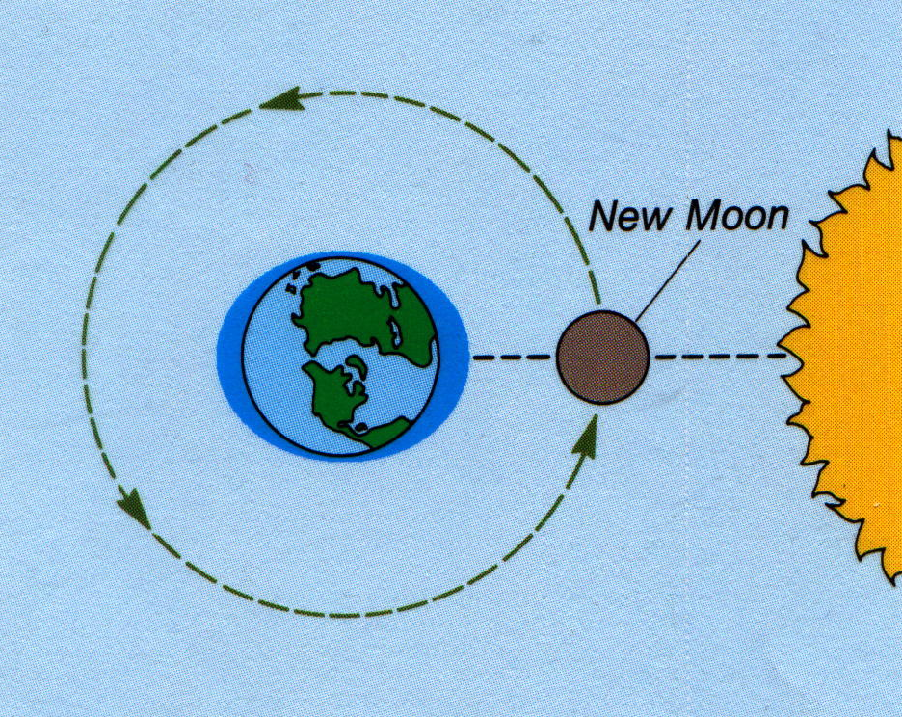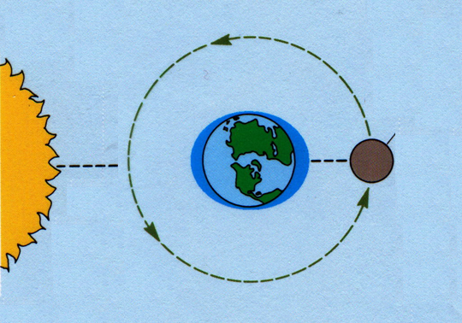

Spring Tide:
A spring tide occurs twice a month during a full or new moon. When the moon and the sun are on the same side of the Earth the gravity from both bodies pull on the oceans causing larger than normal tides. When they are on opposite sides the gravity and centrifugal forces align causing larger tides.

