Colonial Forge High School
Mr. Stribling’s Earth Science Class

Step 1: Colonial Forge’s fusion website address is www.cfhs.org .

Step 2: Logging In: The log in box is located on the bottom left side of the page.

Username: The school has already assigned you a user name. Your user name is the first 8 letters of your last name, the first 6 letters of you first name and the first letter of your middle name. (ex. William Robert Chambers- chamberswilliar)

Password: Your password is preset to your birthday. (mmddyy)

Step 3: Update Your Personal Settings: First, click on personal settings tab on the left side of your screen.





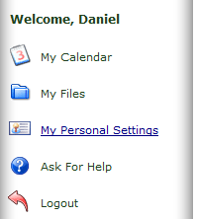

Then change your password and enter an up to date email address.

Step 4: Joining class: Click on the “Forge Classes” tab on the left side of your screen.

Then change your password and enter an up to date email address.

My class will be listed under the “Science” category.

Once you have selected the science tab, find the Earth Science class with Mr. Stribling listed below it.

You will then have to select my class and request to join. You will have full access to my website once I approve your request.

